**ER Diagram**

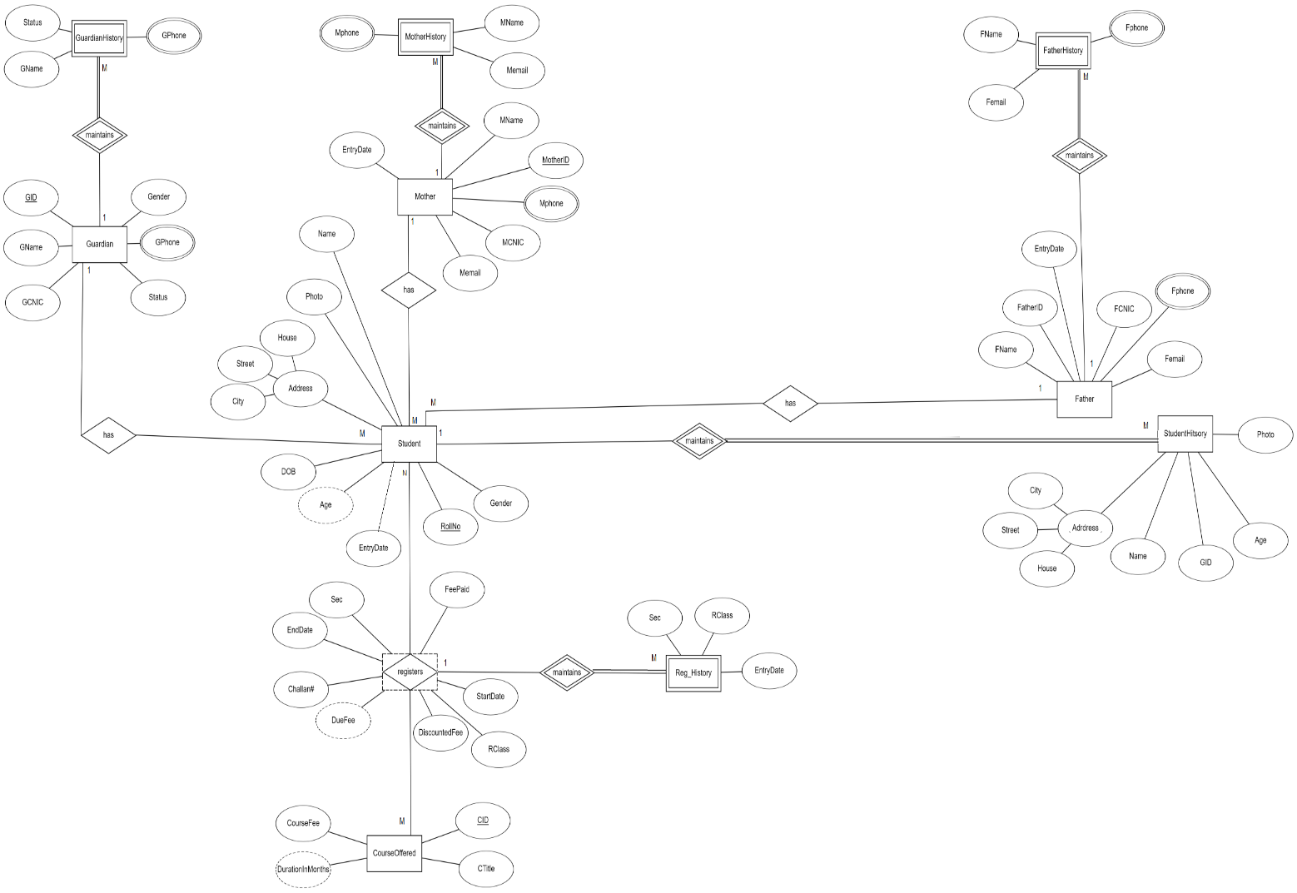

**Schema Diagram**

**Mother**

|  |  |  |  |  |  |
| --- | --- | --- | --- | --- | --- |
| **MID** | MCNIC | MName | Mphone | Memail | EntryDate |

**Mother_History**

|  |  |  |  |  |
| --- | --- | --- | --- | --- |
| ***MID*** | **SrNo** | MName | Mphone | Memail |

**Father**

|  |  |  |  |  |  |
| --- | --- | --- | --- | --- | --- |
| **FID** | FCNIC | FName | Fphone | Femail | EntryDate |

**Father_History**

|  |  |  |  |  |
| --- | --- | --- | --- | --- |
| ***FID*** | **SrNo** | FName | Fphone | Femail |

**Guardian**

|  |  |  |  |  |  |  |
| --- | --- | --- | --- | --- | --- | --- |
| **GID** | GCNIC | GName | Gphone | Gender | Status | relation |

**Guardian_History**

|  |  |  |  |  |
| --- | --- | --- | --- | --- |
| ***GID*** | **SrNo** | GName | Gphone | Status |

**Students**

|  |  |  |  |  |  |  |  |  |  |  |  |  |
| --- | --- | --- | --- | --- | --- | --- | --- | --- | --- | --- | --- | --- |
| **RollNo** | Name | Gender | DOB | Age | Photo | House | Street | City | EntryDate | *GID* | *FID* | *MID* |

**Student_History**

|  |  |  |  |  |  |  |  |  |
| --- | --- | --- | --- | --- | --- | --- | --- | --- |
| ***RollNo*** | **SrNo** | Name | Age | House | Street | City | Photo | GID |

**Courses_Offered**

|  |  |  |  |
| --- | --- | --- | --- |
| **CID** | CTitle | CourseFee | Duration |

**Registration**

|  |  |  |  |  |  |  |  |  |  |  |
| --- | --- | --- | --- | --- | --- | --- | --- | --- | --- | --- |
| ***RollNo*** | ***CID*** | **SrNo** | Class | Sec | StartDate | EndDate | Discounted  Fee | FeePaid | DueFee | Challan# |

**Registration_History**

|  |  |  |  |  |  |  |
| --- | --- | --- | --- | --- | --- | --- |
| ***RollNo*** | ***CID*** | ***SrNO*** | **rNO** | Class | Sec | EntryDate |

**Tables Description**

**Mother**

|  |  |  |  |  |
| --- | --- | --- | --- | --- |
| **MID** | Mother identifier | PK | NUMBER(6) |  |
| MCNIC | Mother CNIC |  | VC(20) |  |
| MName | Mother Name |  | VC(20) |  |
| Mphone | Mother Phone |  | VC(20) |  |
| Memail | Mother email |  | VC(30) |  |
| EntryDate | Date of the mother added to the database |  | DATE |  |

**Mother_History**

|  |  |  |  |  |
| --- | --- | --- | --- | --- |
| ***MID*** | Mother identifier | FK,PK | NUMBER(6) | Ref Mother |
| **SrNo** | Mother identifier along with serial no | INDXU,PK | INT |  |
| MName | Mother Name |  | VC(20) |  |
| Mphone | Mother Phone |  | VC(20) |  |
| Memail | Mother email |  | VC(30) |  |

|  |  |  |  |  |
| --- | --- | --- | --- | --- |
| **FID** | Father identifier | PK | NUMBER(6) |  |
| FCNIC | Father CNIC |  | VC(20) |  |
| FName | Father Name |  | VC(20) |  |
| Fphone | Father Phone |  | VC(20) |  |
| Femail | Father email |  | VC(30) |  |
| EntryDate | Date of the Father added to the database |  | DATE |  |

**Father**

**Father_History**

|  |  |  |  |  |
| --- | --- | --- | --- | --- |
| ***FID*** | Father identifier | FK,PK | NUMBER(6) | Ref Father |
| **SrNo** | Father identifier along with serial no | INDXU,PK | INT |  |
| FName | Father Name |  | VC(20) |  |
| Fphone | Father Phone |  | VC(20) |  |
| Femail | Mother email |  | VC(30) |  |

**Guardian**

|  |  |  |  |  |
| --- | --- | --- | --- | --- |
| **GID** | Guardian identifier | PK | PK | NUMBER(6) |
| GCNIC | Guardian CNIC |  | INT | VC2(20) |
| GName | Guardian Name |  | VC(20) | VC2(20) |
| GPhone | Guardian Phone |  | VC(20) | VC2(20) |
| Gender | M/F |  | CHAR | Char |
| Status | Pregnant/Handicapped |  |  | VC2(30) |
| Relation | Relation to students |  |  | VC2(20) |

**Guardian_History**

|  |  |  |  |  |
| --- | --- | --- | --- | --- |
| ***GID*** | Guardian identifier | FK,PK | INT | Ref Gaurdian |
| **SrNo** | Guardian identifier along with serial no | INDXU,PK | INT |  |
| GName | Guardian Name |  | VC(20) |  |
| Gphone | Guardian Phone |  | VC(20) |  |
| Status |  |  | VC(30) |  |

**Student**

|  |  |  |  |  |
| --- | --- | --- | --- | --- |
| **RollNo** | Student Identifier | PK | NUMBER(4) |  |
| SName | StudentName |  | VC2(20) |  |
| Gender | Student Gender |  | CHAR(1) |  |
| DOB | Student DOB |  | DATE |  |
| Age | Student Age |  | NUMBER(2) |  |
| House | Student House No |  | VC2(10) |  |
| Street | Student street No |  | VC2(20) |  |
| City | Student City |  | VC2(10) |  |
| Photo | Student Photo |  | VC2(30) |  |
| EntryDate | Date of the student got admission and was added to the database |  | DATE |  |
| ***GID*** | Guardian identifier | FK | NUMBER(6) | Ref Guardian |
| ***FID*** | Father identifier | FK | NUMBER(6) | Ref Father |
| ***MID*** | Mother identifier | FK | NUMBER(6) | Ref Mother |

**Student_History**

|  |  |  |  |  |
| --- | --- | --- | --- | --- |
| ***RollNo*** | Student Identifier | FK,PK | NUMBER(4) | Ref Student |
| **SrNo** | Student Identifier with Serial No | INDXU,PK | INT |  |
| GID | Guardian identifier |  | NUMBER(6) |  |
| Name | StudentName |  | VC2(20) |  |
| Age | Student Age |  | NUMBER(2) |  |
| House | Student House No |  | VC2(10) |  |
| Street | Student street No |  | VC2(20) |  |
| City | Student City |  | VC2(10) |  |
| Photo | Student Photo |  | VC2(30) |  |

**Courses_Offered**

|  |  |  |  |  |
| --- | --- | --- | --- | --- |
| **CID** | Course identifier | PK | VC2(6) |  |
| CTitle | Course Title |  | VC2(50) |  |
| CourseFee | Course Fee |  | NUMBER(5) |  |
| Duration_in_Months | Course Duration |  | NUMBER(2) |  |

**Registration**

|  |  |  |  |  |
| --- | --- | --- | --- | --- |
| ***RollNo*** | Student identifier | FK,PK | NUMBER(4) | Ref Student |
| ***CID*** | Course identifier | FK,PK | VC2(6) | Ref Course |
| **SrNo** | Registration no along with Student identifier and course identifier | INDXY,PK | INT |  |
| Class | Student class |  | CHAR |  |
| Sec | Student section of course |  | CHAR |  |
| StartDate | Student Registration Date/Start of Classes Date |  | DATE |  |
| EndDate | End of classes Date |  | DATE |  |
| FeePaid | Amount of fee paid |  | FLOAT(4) |  |
| DiscountedFee | Discount on fee |  | FLOAT(4) |  |
| DueFee | Amount of fee due |  | FLOAT(4) |  |
| Challan# | Voucher Number  Of Challan received from Bank(Third Party) |  | VC2(30) |  |

**Registration_History**

|  |  |  |  |  |
| --- | --- | --- | --- | --- |
| ***RollNo*** | Student identifier | FK,PK | NUMBER(4) | Ref Registration |
| ***CID*** | Course identifier | FK,PK | VC2(6) | Ref Registration |
| **SrNO** | Registration no | FK,PK | INT | Ref Registration |
| **Rno** |  | INDXY,PK | INT |  |
| Class | Student class |  | CHAR |  |
| Sec | Student section of course |  | CHAR |  |
| EntryDate | Date of the registration into a class added to the database |  | DATE |  |

**DATA SETS**

**MOTHER**

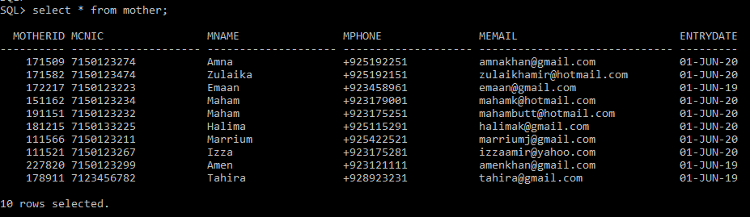

**MOTHER_HISTORY**

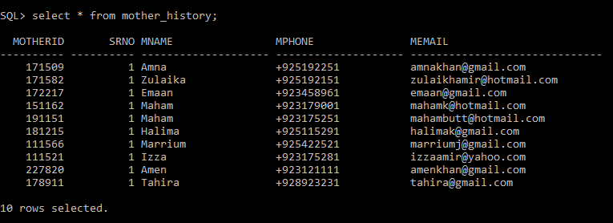

**FATHER**

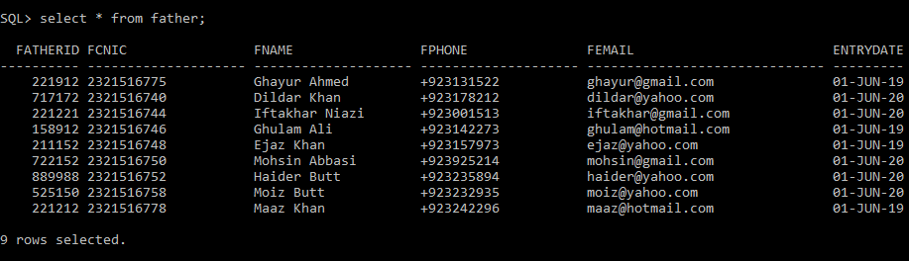

**FATHER_HISTORY**

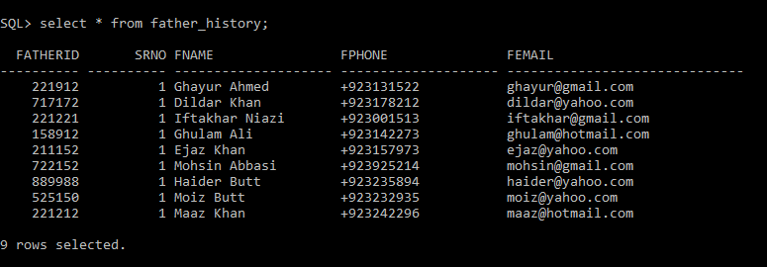

**GUARDIAN**

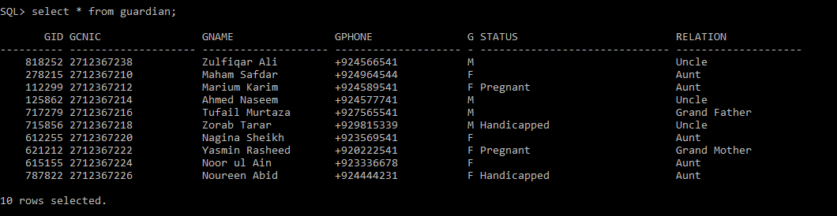

**GUARDIAN_HISTORY**

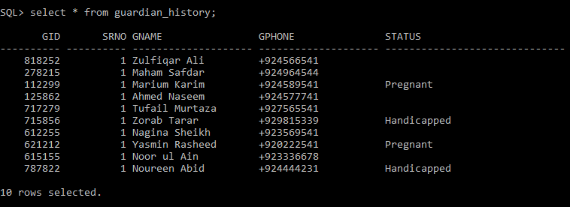

**STUDENT**

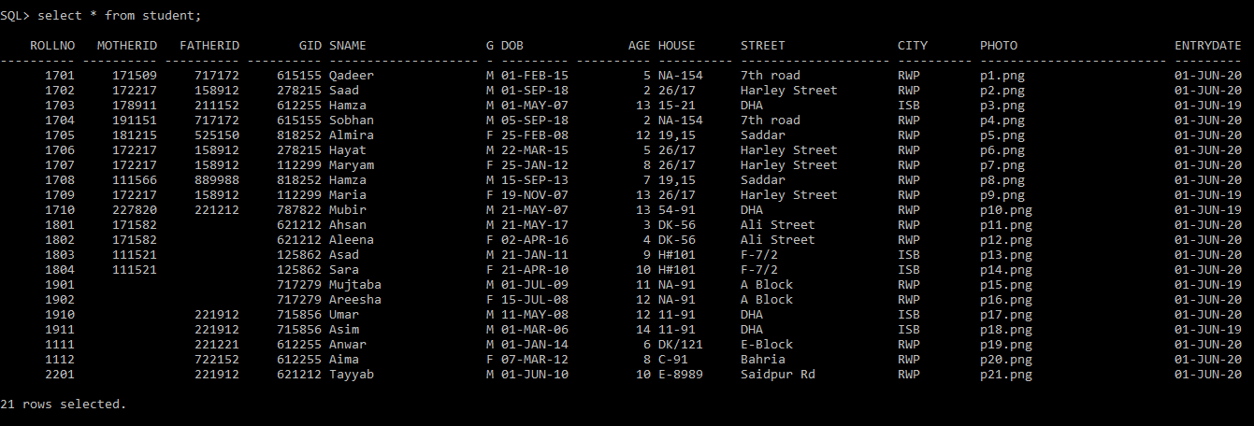

**STUDENT_HISTORY**

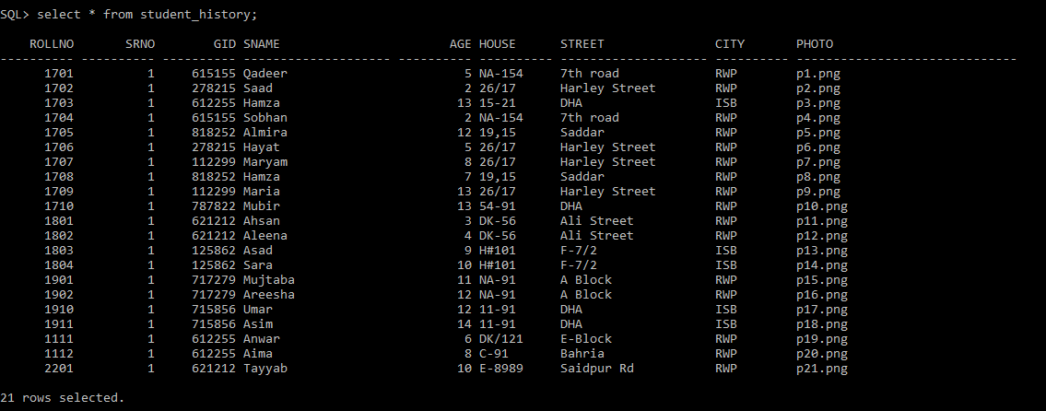

**COURSES_OFFERED**

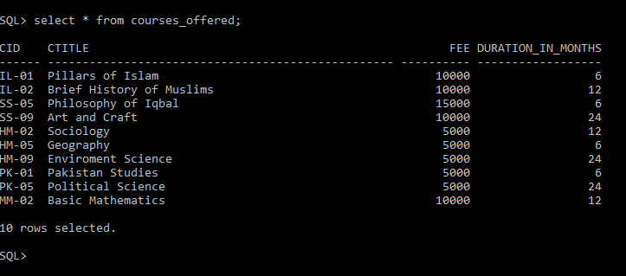

**REGISTRATION**

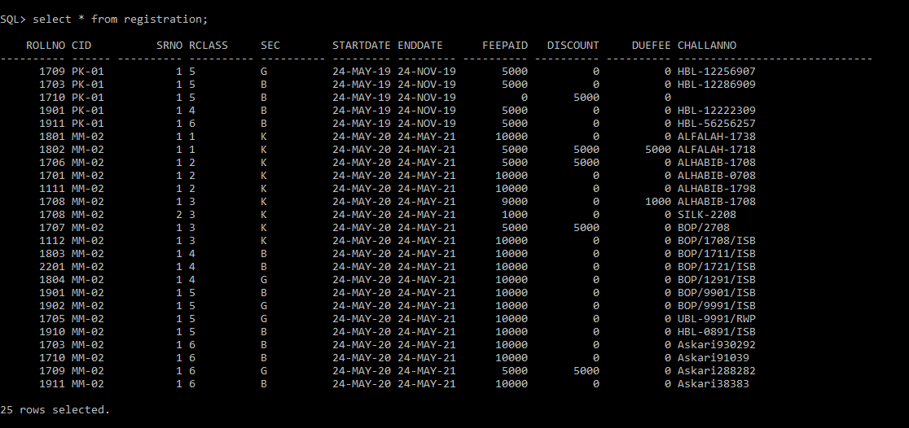

**REGISTRATION_HISTORY**

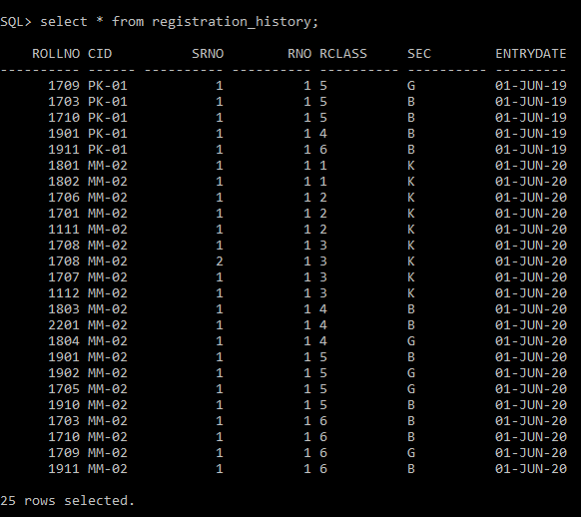

**DDL**

* **SQL statements used to create tables.**
* **SQL statements used to populate tables (insert statements).**

**/* MOTHERS Table */**

**Create table Mother**

**(**

**MotherID number(6),**

**MCNIC varchar2(20),**

**MName varchar2(20) NOT NULL,**

**Mphone varchar2(20) NOT NULL,**

**Memail varchar2(30),**

**EntryDate date default sysdate,**

**CONSTRAINT pk_Mother primary key (MotherID)**

**);**

**/* Inserting values in MOTHERS Table */**

**Insert into Mother (MotherID,MCNIC,MName,Mphone,Memail)**

**Values ('171509','7150123274','Amna','+925192251','amnakhan@gmail.com');**

**Insert into Mother (MotherID,MCNIC,MName,Mphone,Memail)**

**Values ('171582','7150123474','Zulaika','+925192151','zulaikhamir@hotmail.com');**

**Insert into Mother (MotherID,MCNIC,MName,Mphone,Memail,EntryDate)**

**Values ('172217','7150123223','Emaan','+923458961','emaan@gmail.com',add_months(sysdate,-12));**

**Insert into Mother (MotherID,MCNIC,MName,Mphone,Memail)**

**Values ('151162','7150123234','Maham','+923179001','mahamk@hotmail.com');**

**Insert into Mother (MotherID,MCNIC,MName,Mphone,Memail)**

**Values ('191151','7150123232','Maham','+923175251','mahambutt@hotmail.com');**

**Insert into Mother (MotherID,MCNIC,MName,Mphone,Memail)**

**Values ('181215','7150133225','Halima','+925115291','halimak@gmail.com');**

**Insert into Mother (MotherID,MCNIC,MName,Mphone,Memail)**

**Values ('111566','7150123211','Marrium','+925422521','marriumj@gmail.com');**

**Insert into Mother (MotherID,MCNIC,MName,Mphone,Memail)**

**Values ('111521','7150123267','Izza','+923175281','izzaamir@yahoo.com');**

**Insert into Mother (MotherID,MCNIC,MName,Mphone,Memail,EntryDate)**

**Values ('227820','7150123299','Amen','+923121111','amenkhan@gmail.com',add_months(sysdate,-12));**

**Insert into Mother (MotherID,MCNIC,MName,Mphone,Memail,EntryDate)**

**Values ('178911','7123456782','Tahira','+928923231','tahira@gmail.com',add_months(sysdate,-12));**

**/* MOTHERS_HISTORY Table */**

**Create table Mother_History**

**(**

**MotherID number(6),**

**SrNo int DEFAULT '1',**

**MName varchar2(20) NOT NULL,**

**Mphone varchar2(20) NOT NULL,**

**Memail varchar2(30),**

**FOREIGN KEY (MotherID) REFERENCES Mother(MotherID)**

**);**

**/* Inserting values in MOTHERS_HISTORY Table */**

**Insert into Mother_History(MotherID,MName,Mphone,Memail)**

**Select MotherID,MName,Mphone,Memail**

**From Mother;**

**/* Applying Constraints to MOTHERS_HISTORY table */**

**ALTER TABLE Mother_History**

**ADD CONSTRAINT pk_Mother_History PRIMARY KEY (SrNo,MotherID);**

**/* Triggers for MOTHERS_HISTORY */**

**CREATE OR REPLACE TRIGGER trg_Mother_History**

**Before insert on Mother_History**

**referencing new as new old as old for each row**

**declare**

**begin**

**select nvl(max(SrNo),0) + 1**

**into :new.SrNo**

**from Mother_History**

**where MotherID = :new.MotherID;**

**end;**

**/**

**CREATE TRIGGER Mother_History_insert_trigger**

**AFTER INSERT ON Mother**

**referencing new as new old as old FOR EACH ROW**

**DECLARE**

**BEGIN**

**insert into Mother_History(MotherID,MName,Mphone,Memail)**

**values (:NEW.MotherID,:NEW.MName,:NEW.Mphone,:NEW.Memail);**

**END;**

**/**

**CREATE TRIGGER Mother_History_update_trigger**

**AFTER UPDATE ON Mother**

**referencing new as new old as old FOR EACH ROW**

**DECLARE**

**BEGIN**

**insert into Mother_History(MotherID,MName,Mphone,Memail)**

**values (:NEW.MotherID,:NEW.MName,:NEW.Mphone,:NEW.Memail);**

**END;**

**/**

**CREATE TRIGGER M_History_delete_trigger**

**BEFORE DELETE ON Mother**

**referencing new as new old as old FOR EACH ROW**

**DECLARE**

**BEGIN**

**Delete from Mother_History**

**where MotherID=:OLD.MotherID;**

**END;**

**/**

**/* Father Table */**

**Create table Father**

**(**

**FatherID number(6),**

**FCNIC varchar2(20),**

**FName varchar2(20) NOT NULL,**

**FPhone varchar2(20) NOT NULL,**

**Femail varchar2(30),**

**EntryDate date default sysdate,**

**CONSTRAINT pk_Father primary key (FatherID)**

**);**

**/* Inserting values in Father Table */**

**Insert into Father (FatherID,FCNIC,FName,FPhone,Femail,EntryDate)**

**Values ('221912','2321516775','Ghayur Ahmed','+923131522','ghayur@gmail.com',add_months(sysdate,-12));**

**Insert into Father (FatherID,FCNIC,FName,FPhone,Femail)**

**Values ('717172','2321516740','Dildar Khan','+923178212','dildar@yahoo.com');**

**Insert into Father (FatherID,FCNIC,FName,FPhone,Femail)**

**Values ('221221','2321516744','Iftakhar Niazi','+923001513','iftakhar@gmail.com');**

**Insert into Father (FatherID,FCNIC,FName,FPhone,Femail,EntryDate)**

**Values ('158912','2321516746','Ghulam Ali','+923142273','ghulam@hotmail.com',add_months(sysdate,-12));**

**Insert into Father (FatherID,FCNIC,FName,FPhone,Femail,EntryDate)**

**Values ('211152','2321516748','Ejaz Khan','+923157973','ejaz@yahoo.com',add_months(sysdate,-12));**

**Insert into Father (FatherID,FCNIC,FName,FPhone,Femail)**

**Values ('722152','2321516750','Mohsin Abbasi','+923925214','mohsin@gmail.com');**

**Insert into Father (FatherID,FCNIC,FName,FPhone,Femail)**

**Values ('889988','2321516752','Haider Butt','+923235894','haider@yahoo.com');**

**Insert into Father (FatherID,FCNIC,FName,FPhone,Femail)**

**Values ('525150','2321516758','Moiz Butt','+923232935','moiz@yahoo.com');**

**Insert into Father (FatherID,FCNIC,FName,FPhone,Femail,EntryDate)**

**Values ('221212','2321516778','Maaz Khan','+923242296','maaz@hotmail.com',add_months(sysdate,-12));**

**/* Father_HISTORY Table */**

**Create table Father_History**

**(**

**FatherID number(6),**

**SrNo int DEFAULT '1',**

**FName varchar2(20) NOT NULL,**

**FPhone varchar2(20) NOT NULL,**

**Femail varchar2(30),**

**FOREIGN KEY (FatherID) REFERENCES Father(FatherID)**

**);**

**/* Inserting values in Father_HISTORY Table */**

**Insert into Father_History(FatherID,FName,FPhone,Femail)**

**Select FatherID,FName,FPhone,Femail**

**From Father;**

**/* Applying Constraints to Father_HISTORY table */**

**ALTER TABLE Father_History**

**ADD CONSTRAINT pk_Father_History PRIMARY KEY (SrNo,FatherID);**

**/* Triggers for Father_HISTORY */**

**CREATE OR REPLACE TRIGGER trg_Father_History**

**Before insert on Father_History**

**referencing new as new old as old for each row**

**declare**

**begin**

**select nvl(max(SrNo),0) + 1**

**into :new.SrNo**

**from Father_History**

**where FatherID = :new.FatherID;**

**end;**

**/**

**CREATE TRIGGER Father_History_insert_trigger**

**AFTER INSERT ON Father**

**referencing new as new old as old FOR EACH ROW**

**DECLARE**

**BEGIN**

**insert into Father_History(FatherID,FName,FPhone,Femail)**

**values (:NEW.FatherID,:NEW.FName,:NEW.FPhone,:NEW.Femail);**

**END;**

**/**

**CREATE TRIGGER Father_History_update_trigger**

**AFTER UPDATE ON Father**

**referencing new as new old as old FOR EACH ROW**

**DECLARE**

**BEGIN**

**insert into Father_History(FatherID,FName,FPhone,Femail)**

**values (:NEW.FatherID,:NEW.FName,:NEW.FPhone,:NEW.Femail);**

**END;**

**/**

**CREATE TRIGGER F_History_delete_trigger**

**BEFORE DELETE ON Father**

**referencing new as new old as old FOR EACH ROW**

**DECLARE**

**BEGIN**

**Delete from Father_History**

**where FatherID=:OLD.FatherID;**

**END;**

**/**

**/* GUARDIANS Table */**

**Create table Guardian**

**(**

**GID number(6),**

**GCNIC varchar2(20) NOT NULL,**

**GName varchar2(20) NOT NULL,**

**Gphone varchar2(20) NOT NULL,**

**Gender char NOT NULL CHECK (Gender IN ('M','F')),**

**Status varchar2(30) CHECK (Status IN ('Pregnant','Handicapped')),**

**relation varchar2(20) NOT NULL,**

**CONSTRAINT pk_Guardian primary key (GID)**

**);**

**/* Inserting values in GUARDIANS Table */**

**Insert into Guardian (GID,GCNIC,GName,Gphone,Gender,relation)**

**Values ('818252','2712367238','Zulfiqar Ali','+924566541','M','Uncle');**

**Insert into Guardian (GID,GCNIC,GName,Gphone,Gender,relation)**

**Values ('278215','2712367210','Maham Safdar','+924964544','F','Aunt');**

**Insert into Guardian (GID,GCNIC,GName,Gphone,Gender,Status,relation)**

**Values ('112299','2712367212','Marium Karim','+924589541','F','Pregnant','Aunt');**

**Insert into Guardian (GID,GCNIC,GName,Gphone,Gender,relation)**

**Values ('125862','2712367214','Ahmed Naseem','+924577741','M','Uncle');**

**Insert into Guardian (GID,GCNIC,GName,Gphone,Gender,relation)**

**Values ('717279','2712367216','Tufail Murtaza', '+927565541','M','Grand Father');**

**Insert into Guardian (GID,GCNIC,GName,Gphone,Gender,Status,relation)**

**Values ('715856','2712367218','Zorab Tarar', '+929815339','M','Handicapped','Uncle');**

**Insert into Guardian (GID,GCNIC,GName,Gphone,Gender,relation)**

**Values ('612255','2712367220','Nagina Sheikh', '+923569541','F','Aunt');**

**Insert into Guardian (GID,GCNIC,GName,Gphone,Gender,Status,relation)**

**Values ('621212','2712367222','Yasmin Rasheed', '+920222541','F','Pregnant','Grand Mother');**

**Insert into Guardian (GID,GCNIC,GName,Gphone,Gender,relation)**

**Values ('615155','2712367224','Noor ul Ain', '+923336678','F','Aunt');**

**Insert into Guardian (GID,GCNIC,GName,Gphone,Gender,Status,relation)**

**Values ('787822','2712367226','Noureen Abid', '+924444231' ,'F','Handicapped','Aunt');**

**/* GUARDIANS_HISTORY Table */**

**Create table Guardian_History**

**(**

**GID number(6),**

**SrNo int DEFAULT '1',**

**GName varchar2(20) NOT NULL,**

**Gphone varchar2(20) NOT NULL,**

**Status varchar2(30),**

**FOREIGN KEY (GID) REFERENCES Guardian(GID)**

**);**

**/* Inserting values in GUARDIANS_HISTORY Table */**

**Insert into Guardian_History(GID,GName,Gphone,Status)**

**Select GID,GName,Gphone,Status**

**From Guardian;**

**/* Applying Constraints to GUARDIANS_HISTORY table */**

**ALTER TABLE Guardian_History**

**ADD CONSTRAINT pk_Guardian_History PRIMARY KEY (SrNo,GID);**

**/* Triggers for GUARDIANS_HISTORY */**

**CREATE OR REPLACE TRIGGER trg_Guardian_History**

**Before insert on Guardian_History**

**referencing new as new old as old for each row**

**declare**

**begin**

**select nvl(max(SrNo),0) + 1**

**into :new.SrNo**

**from Guardian_History**

**where GID = :new.GID;**

**end;**

**/**

**CREATE TRIGGER G_History_insert_trigger**

**AFTER INSERT ON Guardian**

**referencing new as new old as old FOR EACH ROW**

**DECLARE**

**BEGIN**

**insert into Guardian_History(GID,GName,Gphone,Status)**

**values (:NEW.GID,:NEW.GName,:NEW.Gphone,:NEW.Status);**

**END;**

**/**

**CREATE TRIGGER G_History_update_trigger**

**AFTER UPDATE ON Guardian**

**referencing new as new old as old FOR EACH ROW**

**DECLARE**

**BEGIN**

**insert into Guardian_History(GID,GName,Gphone,Status)**

**values (:NEW.GID,:NEW.GName,:NEW.Gphone,:NEW.Status);**

**END;**

**/**

**CREATE TRIGGER G_History_delete_trigger**

**BEFORE DELETE ON Guardian**

**referencing new as new old as old FOR EACH ROW**

**DECLARE**

**BEGIN**

**Delete from Guardian_History**

**where GID=:OLD.GID;**

**END;**

**/**

**/* Student Table */**

**Create table Student**

**(**

**RollNo number(4),**

**MotherID number(6),**

**FatherID number(6),**

**GID number(6) NOT NULL,**

**SName varchar2(20) NOT NULL,**

**Gender char NOT NULL CHECK (Gender IN ('M','F')),**

**DOB date,**

**Age number(4) CHECK (Age < 15),**

**House varchar2(10),**

**Street varchar2(20),**

**City varchar2(10),**

**Photo varchar2(25),**

**EntryDate date default sysdate,**

**CONSTRAINT pk_Student primary key (RollNo),**

**CONSTRAINT fk_Student_M foreign key (MotherID) references Mother(MotherID),**

**CONSTRAINT fk_Student_F foreign key (FatherID) references Father(FatherID),**

**CONSTRAINT fk_Student_G foreign key (GID) references Guardian(GID)**

**);**

**Insert into Student( RollNo,MotherID,FatherID,GID,SName,Gender,DOB,Age,House,Street,City,Photo)**

**values ('1701','171509','717172','615155','Qadeer','M',date '2015-02-01',extract(year from sysdate) - extract(year from date '2015-02-01'),'NA-154','7th road','RWP','p1.png');**

**Insert into Student( RollNo,MotherID,FatherID,GID,SName,Gender,DOB,Age,House,Street,City,Photo)**

**values ('1702','172217','158912','278215','Saad','M', date '2018-09-01',extract(year from sysdate) - extract(year from date '2018-09-01'),'26/17','Harley Street','RWP','p2.png');**

**Insert into Student( RollNo,MotherID,FatherID,GID,SName,Gender,DOB,Age,House,Street,City,Photo,EntryDate)**

**values ('1703','178911','211152','612255','Hamza','M',date '2007-05-01',extract(year from sysdate) - extract(year from date '2007-05-01'),'15-21','DHA','ISB','p3.png',add_months(sysdate,-12));**

**Insert into Student( RollNo,MotherID,FatherID,GID,SName,Gender,DOB,Age,House,Street,City,Photo)**

**values ('1704','191151','717172','615155','Sobhan','M',date '2018-09-05',extract(year from sysdate) - extract(year from date '2018-09-05'),'NA-154','7th road','RWP','p4.png');**

**Insert into Student( RollNo,MotherID,FatherID,GID,SName,Gender,DOB,Age,House,Street,City,Photo)**

**values ('1705','181215','525150','818252','Almira','F',date '2008-02-25',extract(year from sysdate) - extract(year from date '2008-02-25'),'19,15', 'Saddar','RWP','p5.png');**

**Insert into Student( RollNo,MotherID,FatherID,GID,SName,Gender,DOB,Age,House,Street,City,Photo)**

**values ('1706','172217','158912','278215','Hayat','M',date '2015-03-22',extract(year from sysdate) - extract(year from date '2015-03-22'),'26/17','Harley Street','RWP','p6.png');**

**Insert into Student( RollNo,MotherID,FatherID,GID,SName,Gender,DOB,Age,House,Street,City,Photo)**

**values ('1707','172217','158912','112299','Maryam','F',date '2012-01-25',extract(year from sysdate) - extract(year from date '2012-01-25'),'26/17','Harley Street','RWP','p7.png');**

**Insert into Student( RollNo,MotherID,FatherID,GID,SName,Gender,DOB,Age,House,Street,City,Photo)**

**values ('1708','111566','889988','818252','Hamza','M',date '2013-09-15',extract(year from sysdate) - extract(year from date '2013-09-15'),'19,15', 'Saddar','RWP','p8.png');**

**Insert into Student( RollNo,MotherID,FatherID,GID,SName,Gender,DOB,Age,House,Street,City,Photo,EntryDate)**

**values ('1709','172217','158912','112299','Maria','F',date '2007-11-19',extract(year from sysdate) - extract(year from date '2007-11-19'),'26/17','Harley Street','RWP','p9.png',add_months(sysdate,-12));**

**Insert into Student( RollNo,MotherID,FatherID,GID,SName,Gender,DOB,Age,House,Street,City,Photo,EntryDate)**

**values ('1710','227820','221212','787822','Mubir','M',date '2007-05-21',extract(year from sysdate) - extract(year from date '2007-05-21'),'54-91' ,'DHA','RWP','p10.png',add_months(sysdate,-12));**

**Insert into Student( RollNo,MotherID,GID,SName,Gender,DOB,Age,House,Street,City,Photo)**

**values ('1801','171582','621212','Ahsan','M',date '2017-05-21',extract(year from sysdate) - extract(year from date '2017-05-21'),'DK-56' ,'Ali Street','RWP','p11.png');**

**Insert into Student( RollNo,MotherID,GID,SName,Gender,DOB,Age,House,Street,City,Photo)**

**values ('1802','171582','621212','Aleena','F',date '2016-04-02',extract(year from sysdate) - extract(year from date '2016-04-02'),'DK-56' ,'Ali Street','RWP','p12.png');**

**Insert into Student( RollNo,MotherID,GID,SName,Gender,DOB,Age,House,Street,City,Photo)**

**values ('1803','111521','125862','Asad','M',date '2011-01-21',extract(year from sysdate) - extract(year from date '2011-01-21'),'H#101' ,'F-7/2','ISB','p13.png');**

**Insert into Student( RollNo,MotherID,GID,SName,Gender,DOB,Age,House,Street,City,Photo)**

**values ('1804','111521','125862','Sara','F',date '2010-04-21',extract(year from sysdate) - extract(year from date '2010-04-21'),'H#101' ,'F-7/2','ISB','p14.png');**

**Insert into Student( RollNo,GID,SName,Gender,DOB,Age,House,Street,City,Photo,EntryDate)**

**values ('1901','717279','Mujtaba','M',date '2009-07-01',extract(year from sysdate) - extract(year from date '2009-07-01'),'NA-91' ,'A Block','RWP','p15.png',add_months(sysdate,-12));**

**Insert into Student( RollNo,GID,SName,Gender,DOB,Age,House,Street,City,Photo)**

**values ('1902','717279','Areesha','F',date '2008-07-15',extract(year from sysdate) - extract(year from date '2008-07-15'),'NA-91' ,'A Block','RWP','p16.png');**

**Insert into Student( RollNo,FatherID,GID,SName,Gender,DOB,Age,House,Street,City,Photo)**

**values ('1910','221912','715856','Umar','M',date '2008-05-11',extract(year from sysdate) - extract(year from date '2008-05-11'),'11-91' ,'DHA','ISB','p17.png');**

**Insert into Student( RollNo,FatherID,GID,SName,Gender,DOB,Age,House,Street,City,Photo,EntryDate)**

**values ('1911','221912','715856','Asim','M',date '2006-03-01',extract(year from sysdate) - extract(year from date '2006-03-01'),'11-91' ,'DHA','ISB','p18.png',add_months(sysdate,-12));**

**Insert into Student( RollNo,FatherID,GID,SName,Gender,DOB,Age,House,Street,City,Photo)**

**values ('1111','221221','612255','Anwar','M',date '2014-01-01',extract(year from sysdate) - extract(year from date '2014-01-01'),'DK/121' ,'E-Block','RWP','p19.png');**

**Insert into Student( RollNo,FatherID,GID,SName,Gender,DOB,Age,House,Street,City,Photo)**

**values ('1112','722152','612255','Aima','F',date '2012-03-07',extract(year from sysdate) - extract(year from date '2012-03-07'),'C-91' ,'Bahria','RWP','p20.png');**

**Insert into Student( RollNo,FatherID,GID,SName,Gender,DOB,Age,House,Street,City,Photo)**

**values ('2201','221912','621212','Tayyab','M',date '2010-06-01',extract(year from sysdate) - extract(year from date '2010-06-01'),'E-8989' ,'Saidpur Rd','RWP','p21.png');**

**Create table Student_History**

**(**

**RollNo number(4),**

**SrNo int DEFAULT '1',**

**GID number(6) NOT NULL,**

**SName varchar2(20) NOT NULL,**

**Age Number(4) CHECK (Age < 15),**

**House varchar2(10),**

**Street varchar2(20),**

**City varchar2(10),**

**Photo varchar2(25),**

**foreign key (RollNo) references Student(RollNo)**

**);**

**/* Inserting values in STUDENTS_HISTORY Table */**

**Insert into Student_History(RollNo,GID,SName,Age,House,Street,City,Photo)**

**Select RollNo,GID,SName,Age,House,Street,City,Photo**

**From Student;**

**/* Applying Constraints to STUDENTS_HISTORY table */**

**ALTER TABLE Student_History**

**ADD CONSTRAINT pk_Student_History PRIMARY KEY (SrNo,RollNo);**

**/* Triggers for STUDENTS_HISTORY */**

**CREATE OR REPLACE TRIGGER trg_Student_History**

**Before insert on Student_History**

**referencing new as new old as old for each row**

**declare**

**begin**

**select nvl(max(SrNo),0) + 1**

**into :new.SrNo**

**from Student_History**

**where RollNo = :new.RollNo;**

**end;**

**/**

**CREATE or replace TRIGGER S_History_insert_trigger**

**AFTER INSERT ON Student**

**referencing new as new old as old FOR EACH ROW**

**DECLARE**

**BEGIN**

**insert into Student_History(RollNo,GID,SName,Age,House,Street,City,Photo)**

**values (:NEW.RollNo,:NEW.GID,:NEW.SName,:NEW.Age,:NEW.House,:NEW.Street,:NEW.City,:NEW.Photo);**

**END;**

**/**

**CREATE or replace TRIGGER S_History_update_trigger**

**AFTER UPDATE ON Student**

**referencing new as new old as old FOR EACH ROW**

**DECLARE**

**BEGIN**

**insert into Student_History(RollNo,GID,SName,Age,House,Street,City,Photo)**

**values (:NEW.RollNo,:NEW.GID,:NEW.SName,:NEW.Age,:NEW.House,:NEW.Street,:NEW.City,:NEW.Photo);**

**END;**

**/**

**CREATE or replace TRIGGER St_History_delete_trigger**

**BEFORE DELETE ON Student**

**referencing new as new old as old FOR EACH ROW**

**DECLARE**

**BEGIN**

**Delete from Student_History**

**where RollNo=:OLD.RollNo;**

**END;**

**/**

**Create Table Courses_Offered**

**(**

**CID varchar2(6),**

**CTitle varchar2(50) NOT NULL,**

**Fee Number(5),**

**Duration_in_Months int,**

**CONSTRAINT pk_Course primary key (CID)**

**);**

**Insert into Courses_Offered(CID,CTitle,Fee,Duration_in_Months)**

**values ('IL-01','Pillars of Islam','10000','6');**

**Insert into Courses_Offered(CID,CTitle,Fee,Duration_in_Months)**

**values ('IL-02','Brief History of Muslims','10000','12');**

**Insert into Courses_Offered(CID,CTitle,Fee,Duration_in_Months)**

**values ('SS-05','Philosophy of Iqbal','15000','6');**

**Insert into Courses_Offered(CID,CTitle,Fee,Duration_in_Months)**

**values ('SS-09','Art and Craft','10000','24');**

**Insert into Courses_Offered(CID,CTitle,Fee,Duration_in_Months)**

**values ('HM-02','Sociology','5000','12');**

**Insert into Courses_Offered(CID,CTitle,Fee,Duration_in_Months)**

**values ('HM-05','Geography','5000','6');**

**Insert into Courses_Offered(CID,CTitle,Fee,Duration_in_Months)**

**values ('HM-09','Enviroment Science','5000','24');**

**Insert into Courses_Offered(CID,CTitle,Fee,Duration_in_Months)**

**values ('PK-01','Pakistan Studies','5000','6');**

**Insert into Courses_Offered(CID,CTitle,Fee,Duration_in_Months)**

**values ('PK-05','Political Science','5000','24');**

**Insert into Courses_Offered(CID,CTitle,Fee,Duration_in_Months)**

**values ('MM-02','Basic Mathematics','10000','12');**

**Create Table Registration(**

**RollNo number(4),**

**CID varchar2(6),**

**SrNo int DEFAULT '1',**

**RClass char(10) CHECK (RClass in('1','2','3','4','5','6')) NOT NULL,**

**Sec char(10) default 'K',CHECK (Sec in('K','G','B')),**

**StartDate Date NOT NULL,**

**EndDate Date,**

**FeePaid float(4) NOT NULL,**

**Discount float(4) default 0.00,**

**DueFee float(4),**

**ChallanNo varchar(30),**

**Foreign key (RollNo) references Student(Rollno),**

**Foreign key (CID) references Courses_Offered(CID),**

**CONSTRAINT pk_Registraion PRIMARY KEY (RollNo,CID,SrNo)**

**);**

**insert into Registration(RollNo,CID,RClass,Sec,StartDate,EndDate,FeePaid,Discount,DueFee,ChallanNO)**

**values ('1709','PK-01','5','G',add_months(sysdate,-12),add_months(add_months(sysdate,-12),6),'5000.00','0.00','0.00','HBL-12256907');**

**insert into Registration(RollNo,CID,RClass,Sec,StartDate,EndDate,FeePaid,Discount,DueFee,ChallanNO)**

**values ('1703','PK-01','5','B',add_months(sysdate,-12),add_months(add_months(sysdate,-12),6),'5000.00','0.00','0.00','HBL-12286909');**

**insert into Registration(RollNo,CID,RClass,Sec,StartDate,EndDate,FeePaid,Discount,DueFee)**

**values ('1710','PK-01','5','B',add_months(sysdate,-12),add_months(add_months(sysdate,-12),6),'0.00','5000.00','0.00');**

**insert into Registration(RollNo,CID,RClass,Sec,StartDate,EndDate,FeePaid,Discount,DueFee,ChallanNO)**

**values ('1901','PK-01','4','B',add_months(sysdate,-12),add_months(add_months(sysdate,-12),6),'5000.00','0.00','0.00','HBL-12222309');**

**insert into Registration(RollNo,CID,RClass,Sec,StartDate,EndDate,FeePaid,Discount,DueFee,ChallanNO)**

**values ('1911','PK-01','6','B',add_months(sysdate,-12),add_months(add_months(sysdate,-12),6),'5000.00','0.00','0.00','HBL-56256257');**

**CREATE OR REPLACE TRIGGER trg_Registration**

**Before insert on Registration**

**referencing new as new old as old for each row**

**declare**

**begin**

**select nvl(max(SrNo),0) + 1**

**into :new.SrNo**

**from Registration**

**where RollNo = :new.RollNo and CID = :new.CID;**

**end;**

**/**

**insert into Registration(RollNo,CID,RClass,Sec,StartDate,EndDate,FeePaid,Discount,DueFee,ChallanNO)**

**values ('1801','MM-02','1','K',sysdate,add_months(sysdate,12),'10000.00','0.00','0.00','ALFALAH-1738');**

**insert into Registration(RollNo,CID,RClass,Sec,StartDate,EndDate,FeePaid,Discount,DueFee,ChallanNO)**

**values ('1802','MM-02','1','K',sysdate,add_months(sysdate,12),'5000.00','5000.00','5000.00','ALFALAH-1718');**

**insert into Registration(RollNo,CID,RClass,Sec,StartDate,EndDate,FeePaid,Discount,DueFee,ChallanNO)**

**values ('1706','MM-02','2','K',sysdate,add_months(sysdate,12),'5000.00','5000.00','0.00','ALHABIB-1708');**

**insert into Registration(RollNo,CID,RClass,Sec,StartDate,EndDate,FeePaid,Discount,DueFee,ChallanNO)**

**values ('1701','MM-02','2','K',sysdate,add_months(sysdate,12),'10000.00','0.00','0.00','ALHABIB-0708');**

**insert into Registration(RollNo,CID,RClass,Sec,StartDate,EndDate,FeePaid,Discount,DueFee,ChallanNO)**

**values ('1111','MM-02','2','K',sysdate,add_months(sysdate,12),'10000.00','0.00','0.00','ALHABIB-1798');**

**insert into Registration(RollNo,CID,RClass,Sec,StartDate,EndDate,FeePaid,Discount,DueFee,ChallanNO)**

**values ('1708','MM-02','3','K',sysdate,add_months(sysdate,12),'9000.00','0.00','1000.00','ALHABIB-1708');**

**insert into Registration(RollNo,CID,RClass,Sec,StartDate,EndDate,FeePaid,Discount,DueFee,ChallanNO)**

**values ('1708','MM-02','3','K',sysdate,add_months(sysdate,12),'1000.00','0.00','0.00','SILK-2208');**

**insert into Registration(RollNo,CID,RClass,Sec,StartDate,EndDate,FeePaid,Discount,DueFee,ChallanNO)**

**values ('1707','MM-02','3','K',sysdate,add_months(sysdate,12),'5000.00','5000.00','0.00','BOP/2708');**

**insert into Registration(RollNo,CID,RClass,Sec,StartDate,EndDate,FeePaid,Discount,DueFee,ChallanNO)**

**values ('1112','MM-02','3','K',sysdate,add_months(sysdate,12),'10000.00','0.00','0.00','BOP/1708/ISB');**

**insert into Registration(RollNo,CID,RClass,Sec,StartDate,EndDate,FeePaid,Discount,DueFee,ChallanNO)**

**values ('1803','MM-02','4','B',sysdate,add_months(sysdate,12),'10000.00','0.00','0.00','BOP/1711/ISB');**

**insert into Registration(RollNo,CID,RClass,Sec,StartDate,EndDate,FeePaid,Discount,DueFee,ChallanNO)**

**values ('2201','MM-02','4','B',sysdate,add_months(sysdate,12),'10000.00','0.00','0.00','BOP/1721/ISB');**

**insert into Registration(RollNo,CID,RClass,Sec,StartDate,EndDate,FeePaid,Discount,DueFee,ChallanNO)**

**values ('1804','MM-02','4','G',sysdate,add_months(sysdate,12),'10000.00','0.00','0.00','BOP/1291/ISB');**

**insert into Registration(RollNo,CID,RClass,Sec,StartDate,EndDate,FeePaid,Discount,DueFee,ChallanNO)**

**values ('1901','MM-02','5','B',sysdate,add_months(sysdate,12),'10000.00','0.00','0.00','BOP/9901/ISB');**

**insert into Registration(RollNo,CID,RClass,Sec,StartDate,EndDate,FeePaid,Discount,DueFee,ChallanNO)**

**values ('1902','MM-02','5','G',sysdate,add_months(sysdate,12),'10000.00','0.00','0.00','BOP/9991/ISB');**

**insert into Registration(RollNo,CID,RClass,Sec,StartDate,EndDate,FeePaid,Discount,DueFee,ChallanNO)**

**values ('1705','MM-02','5','G',sysdate,add_months(sysdate,12),'10000.00','0.00','0.00','UBL-9991/RWP');**

**insert into Registration(RollNo,CID,RClass,Sec,StartDate,EndDate,FeePaid,Discount,DueFee,ChallanNO)**

**values ('1910','MM-02','5','B',sysdate,add_months(sysdate,12),'10000.00','0.00','0.00','HBL-0891/ISB');**

**insert into Registration(RollNo,CID,RClass,Sec,StartDate,EndDate,FeePaid,Discount,DueFee,ChallanNO)**

**values ('1703','MM-02','6','B',sysdate,add_months(sysdate,12),'10000.00','0.00','0.00','Askari930292');**

**insert into Registration(RollNo,CID,RClass,Sec,StartDate,EndDate,FeePaid,Discount,DueFee,ChallanNO)**

**values ('1710','MM-02','6','B',sysdate,add_months(sysdate,12),'10000.00','0.00','0.00','Askari91039');**

**insert into Registration(RollNo,CID,RClass,Sec,StartDate,EndDate,FeePaid,Discount,DueFee,ChallanNO)**

**values ('1709','MM-02','6','G',sysdate,add_months(sysdate,12),'5000.00','5000.00','0.00','Askari288282');**

**insert into Registration(RollNo,CID,RClass,Sec,StartDate,EndDate,FeePaid,Discount,DueFee,ChallanNO)**

**values ('1911','MM-02','6','B',sysdate,add_months(sysdate,12),'10000.00','0.00','0.00','Askari38383');**

**Create Table Registration_History(**

**RollNo number(4),**

**CID varchar2(6),**

**SrNo int ,**

**rNO int Default '1',**

**RClass char(10),**

**Sec char(10) ,**

**EntryDate date default sysdate,**

**Foreign key (RollNo,CID,SrNo) references Registration(RollNo,CID,SrNo)**

**);**

**Insert into Registration_History(RollNo,CID,SrNo,RClass,Sec,EntryDate)**

**Select RollNo,CID,SrNo,RClass,Sec,StartDate**

**From registration;**

**ALTER TABLE Registration_History**

**ADD CONSTRAINT pk_Registration_History PRIMARY KEY (RollNo,CID,SrNo,rNO);**

**CREATE OR REPLACE TRIGGER trg_Registration_History**

**Before insert on Registration_History**

**referencing new as new old as old for each row**

**declare**

**begin**

**select nvl(max(rNo),0) + 1**

**into :new.rNo**

**from Registration_History**

**where RollNo = :new.RollNo and CID = :new.CID and SrNo=:new.SrNo;**

**end;**

**/**

**CREATE or replace TRIGGER R_History_insert_trigger**

**AFTER INSERT ON Registration**

**referencing new as new old as old FOR EACH ROW**

**DECLARE**

**BEGIN**

**insert into Registration_History(RollNo,CID,SrNo,RClass,Sec)**

**values (:new.RollNo,:new.CID,:new.SrNo,:new.RClass,:new.Sec);**

**END;**

**/**

**CREATE or replace TRIGGER R_History_update_trigger**

**AFTER UPDATE ON Registration**

**referencing new as new old as old FOR EACH ROW**

**DECLARE**

**BEGIN**

**insert into Registration_History(RollNo,CID,SrNo,RClass,Sec)**

**values (:new.RollNo,:new.CID,:new.SrNo,:new.RClass,:new.Sec);**

**END;**

**/**

**CREATE or replace TRIGGER R_History_delete_trigger**

**BEFORE DELETE ON Registration**

**referencing new as new old as old FOR EACH ROW**

**DECLARE**

**BEGIN**

**Delete from Registration_History**

**where RollNo = :new.RollNo and CID = :new.CID and SrNo = :new.SrNo;**

**END;**

**/**

**SQL statements as the answer to the needed 15 queries**

**QUERY 1 - A list of all students**

**select * from student;**

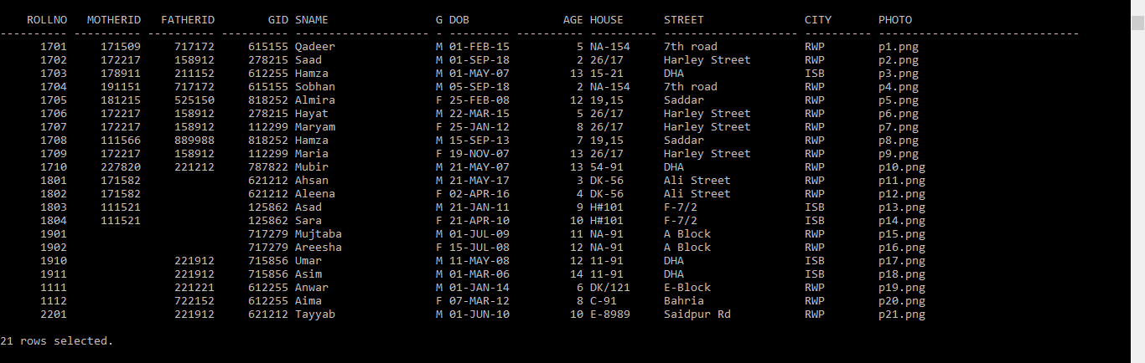

**QUERY 2 - A LIST OF ALL MOTHERS AND THEIR SPOUSES**

**select DISTINCT m.*,f.fname SpouseName**

**from mother m,father f,student s**

**where m.motherid=s.motherid**

**and f.fatherid=s.fatherid;**

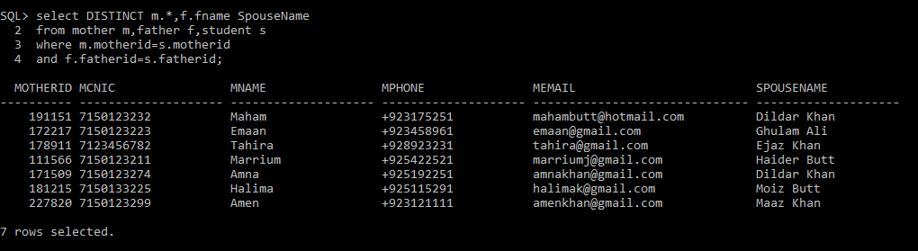

**QUERY 3 - A list of all guardians, grouped by relation to students (show students as well)**

**select g.* ,s.sname Student_Name**

**from guardian g,student s**

**where g.gid=s.gid;**

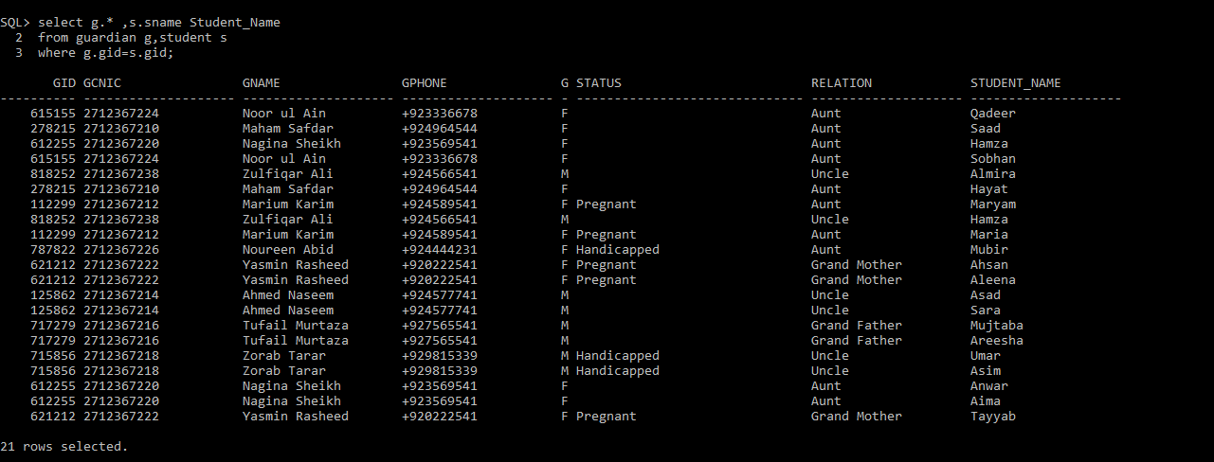

**QUERY 4 - A LIST OF ALL PARENTS AND THEIR CHILDREN**

**select m.motherid,m.mname MOTHER_NAME,f.fatherid,f.fname FATHER_NAME,s.sname CHILD_NAME**

**from mother m,father f,student s**

**where m.motherid(+)=s.motherid**

**and f.fatherid(+)=s.fatherid;**

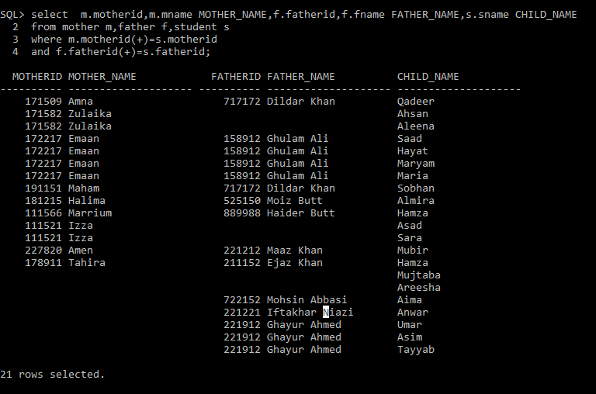

**QUERY 5 - A LIST OF ALL STUDENTS WITH SIBLINGS TAKING CLASSES GROUPED BY CLASS**

**create view registered_students as**

**select DISTINCT r.rollno,r.rclass,s.sname,s.fatherid,s.motherid**

**from registration r,student s**

**where r.rollno=s.rollno;**

**select DISTINCT rr.rollno,rr.rclass,rr.sname STUDENT,rv.sname SIBLING**

**from registered_students rr,registered_students rv**

**where (rr.fatherid=rv.fatherid and rr.rollno!=rv.rollno)**

**OR (rr.motherid=rv.motherid and rr.rollno!=rv.rollno)**

**order by rr.rclass;**

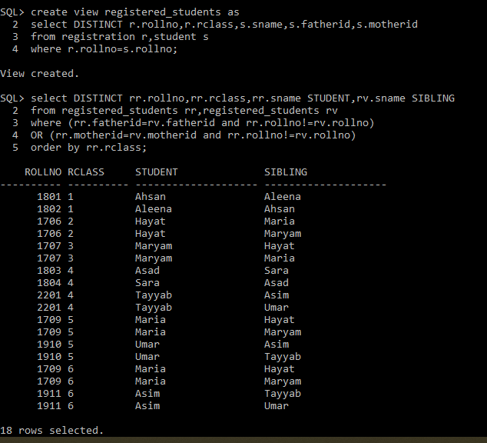

**QUERY 6 - LIST OF STUDENTS HAVE BEEN ASSIGNED TO A NEW CLASS IN GIVEN TIME SPAN**

**update registration**

**set rclass='6'**

**where rollno='1910'**

**and cid='MM-02';**

**select DISTINCT s.\***

**from student s,**

**(select r1.rollno**

**from registration_history r1**

**where r1.rNo!='1') t**

**where s.rollno=t.rollno**

**and EntryDate between '01-JULY-19' and '01-JULY-20';**

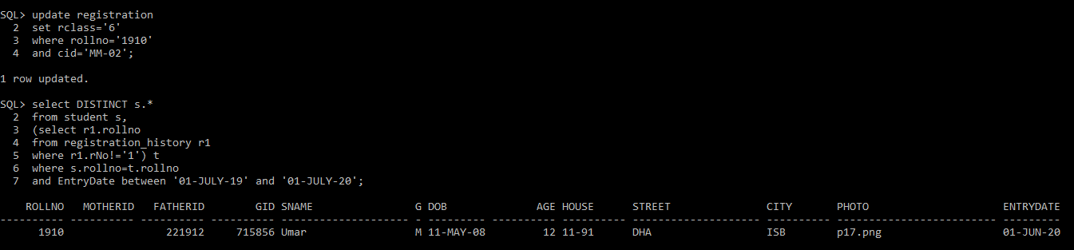

**QUERY 7 - A list of all new students in given time span grouped by class**

**select * from student**

**where EntryDate between '01-JULY-19' and '01-JULY-20';**

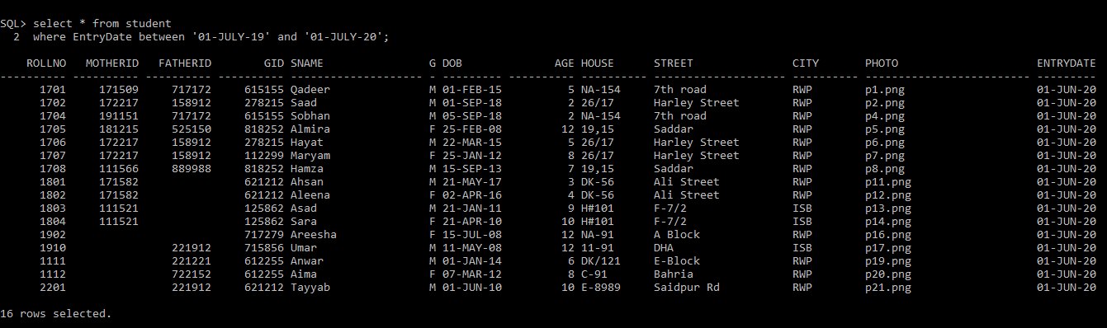

**QUERY 8 - A list of all new parents in given time span (include children info)**

**select m.motherid,m.mname MOTHER_NAME,f.fatherid,f.fname FATHER_NAME,s.sname CHILD_NAME,s.EntryDate**

**from mother m,father f,student s**

**where m.motherid(+)=s.motherid**

**and f.fatherid(+)=s.fatherid**

**and s.EntryDate between '01-JULY-19' and '01-JULY-20';**

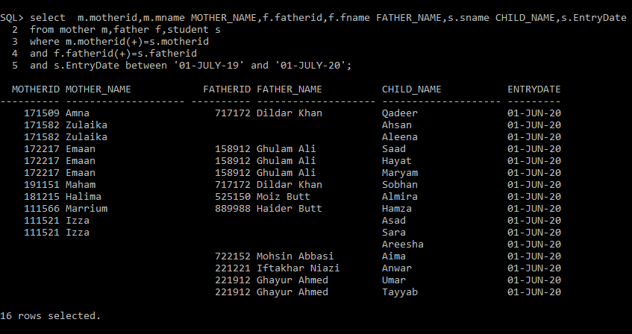

**QUERY 9 - LIST OF PARENTS THAT ARE EARLY INTRODUCERS**

**select m.motherid,m.mname,f.fatherid,f.fname**

**from mother m,father f,(select * from student where age< 3) s**

**where m.motherid(+)=s.motherid**

**and f.fatherid(+)=s.fatherid;**

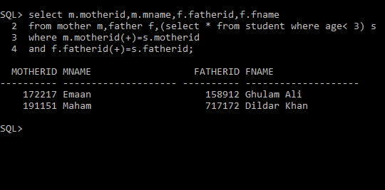

**QUERY 10 - Class change history of given student IN A GIVEN COURSE**

**select rclass,sec**

**from registration_history**

**where rollno='1910' and cid='MM-02';**

